Poll Questions

MODULE 1 - INDICATOR 1.2 SLIDE #15

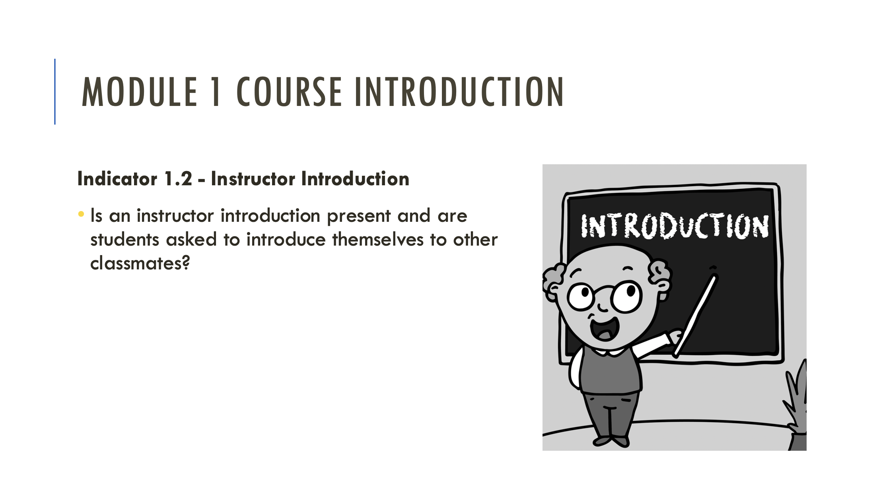

Q: What introduction strategy do you use in your online courses?
  - Introduction Announcement
  - Discussion Board Question
  - Video Introduction
  - None of these

MODULE 2 - INDICATOR 2.5 SLIDE #21

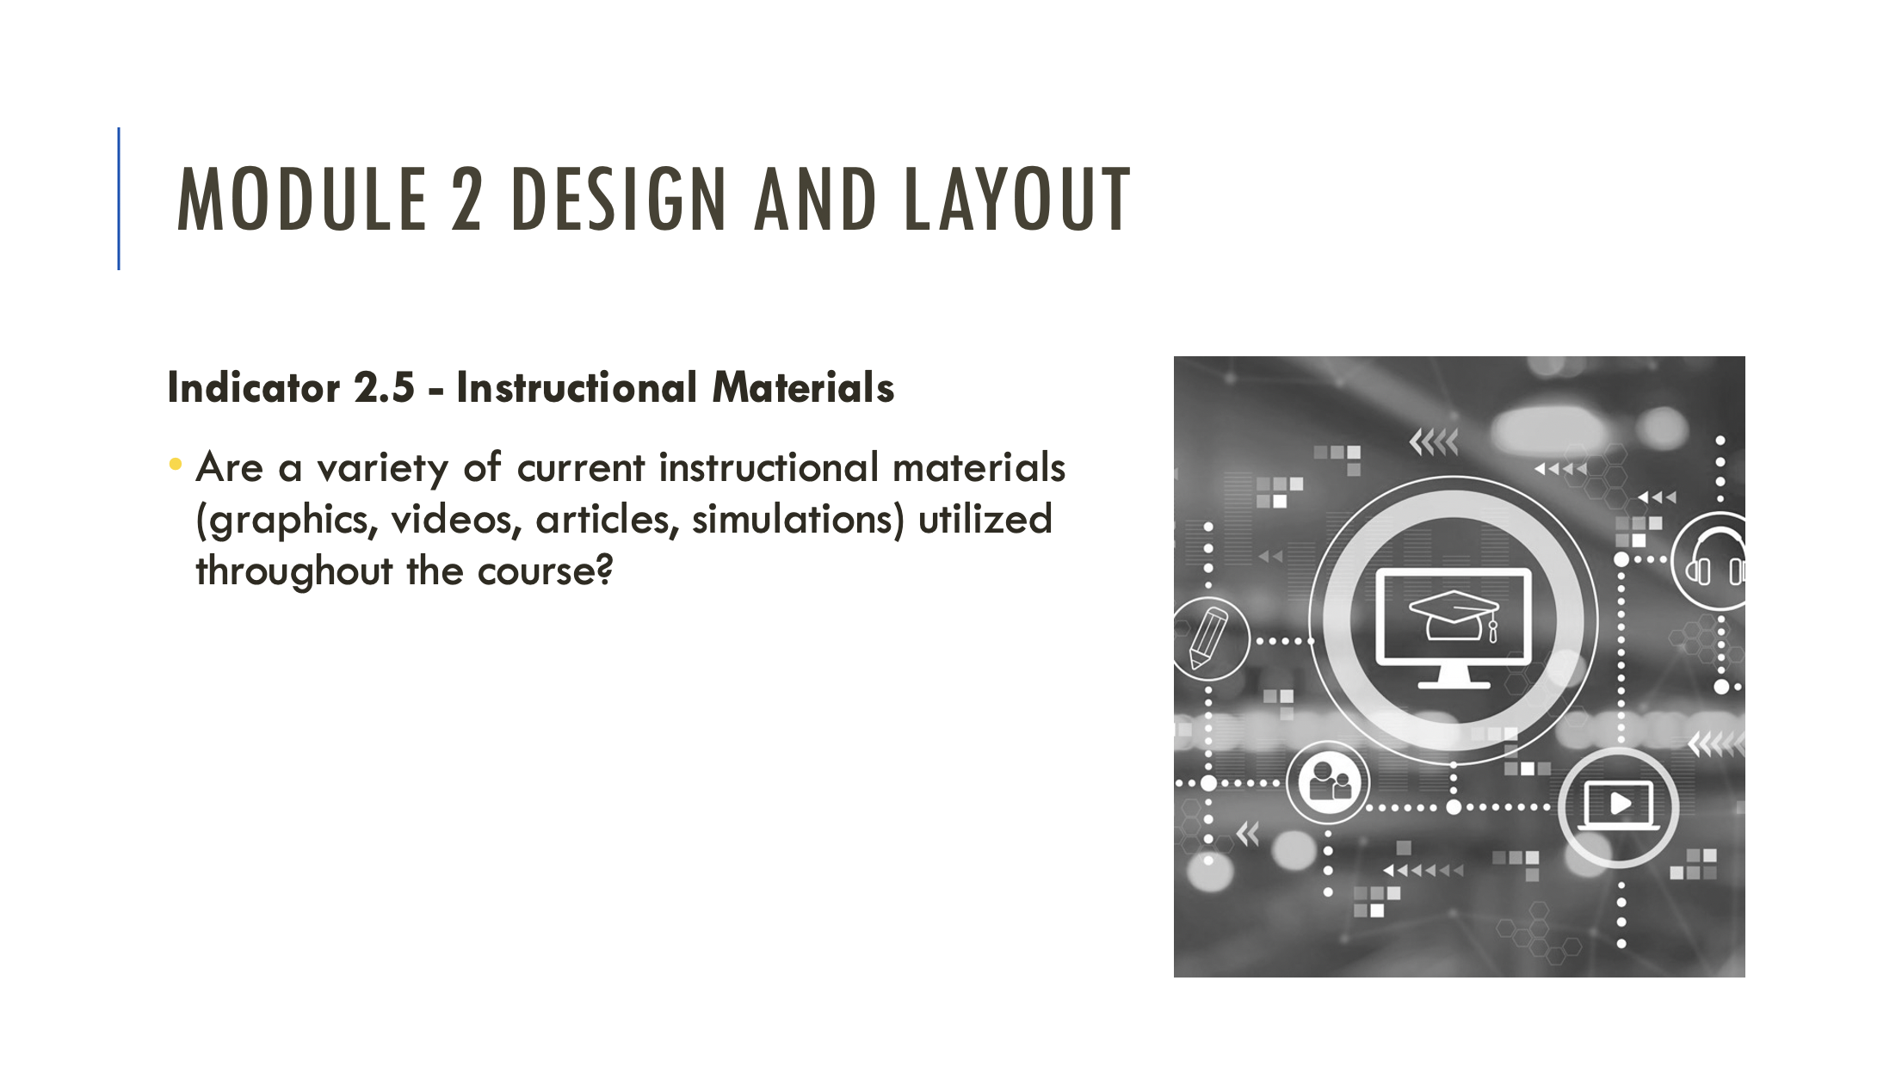

Q: What instructional material do your students best respond to?
  - Videos
  - Articles
  - Interactive Simulations
  - Graphics

MODULE 3 - INDICATOR 3.3 SLIDE #24

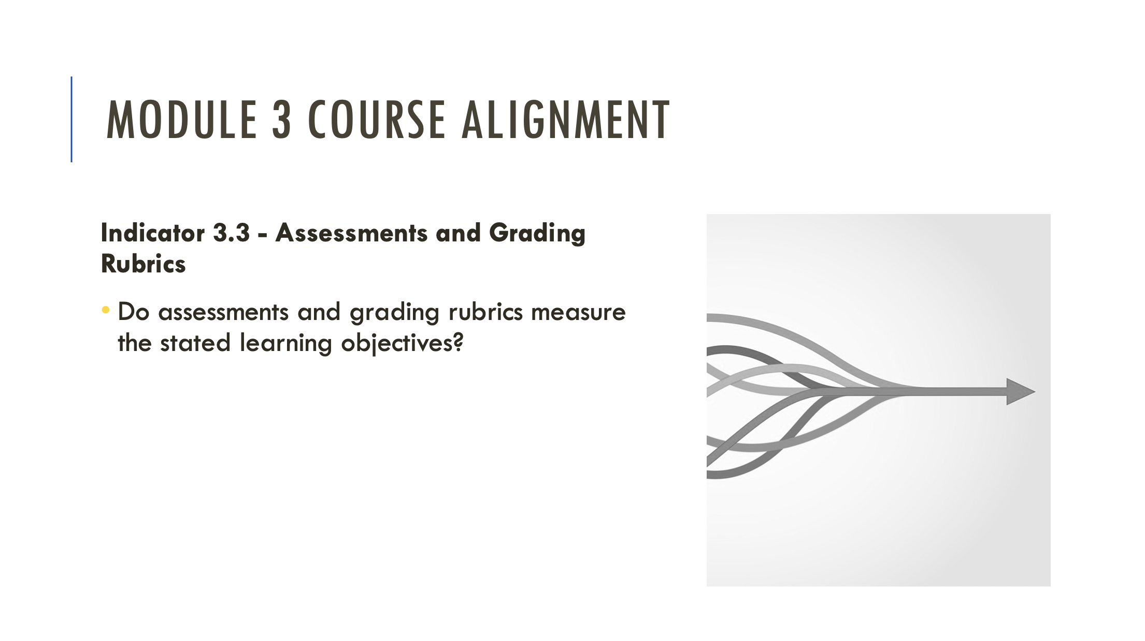

Q: Do you use grading rubrics?
  - Yes, I use rubrics provided by my institution
  - Yes, I create my own rubrics
  - No, I do not use rubrics
  - What’s a rubric?

MODULE 4 - INDICATOR 4.3 SLIDE #27
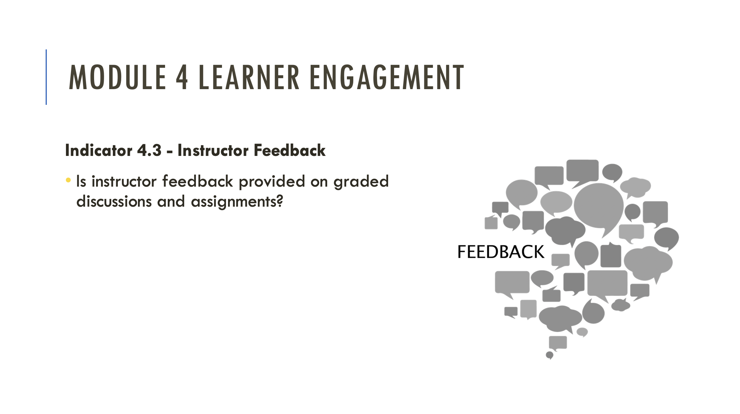

Q: What type of feedback do you provide on graded assignments?
  - I provide individual, personalized feedback to each student
  - I provide canned responses to save time
  - I provide video-based feedback
  - I have students provide peer-based feedback

MODULE 5 - INDICATOR 5.3 SLIDE #30

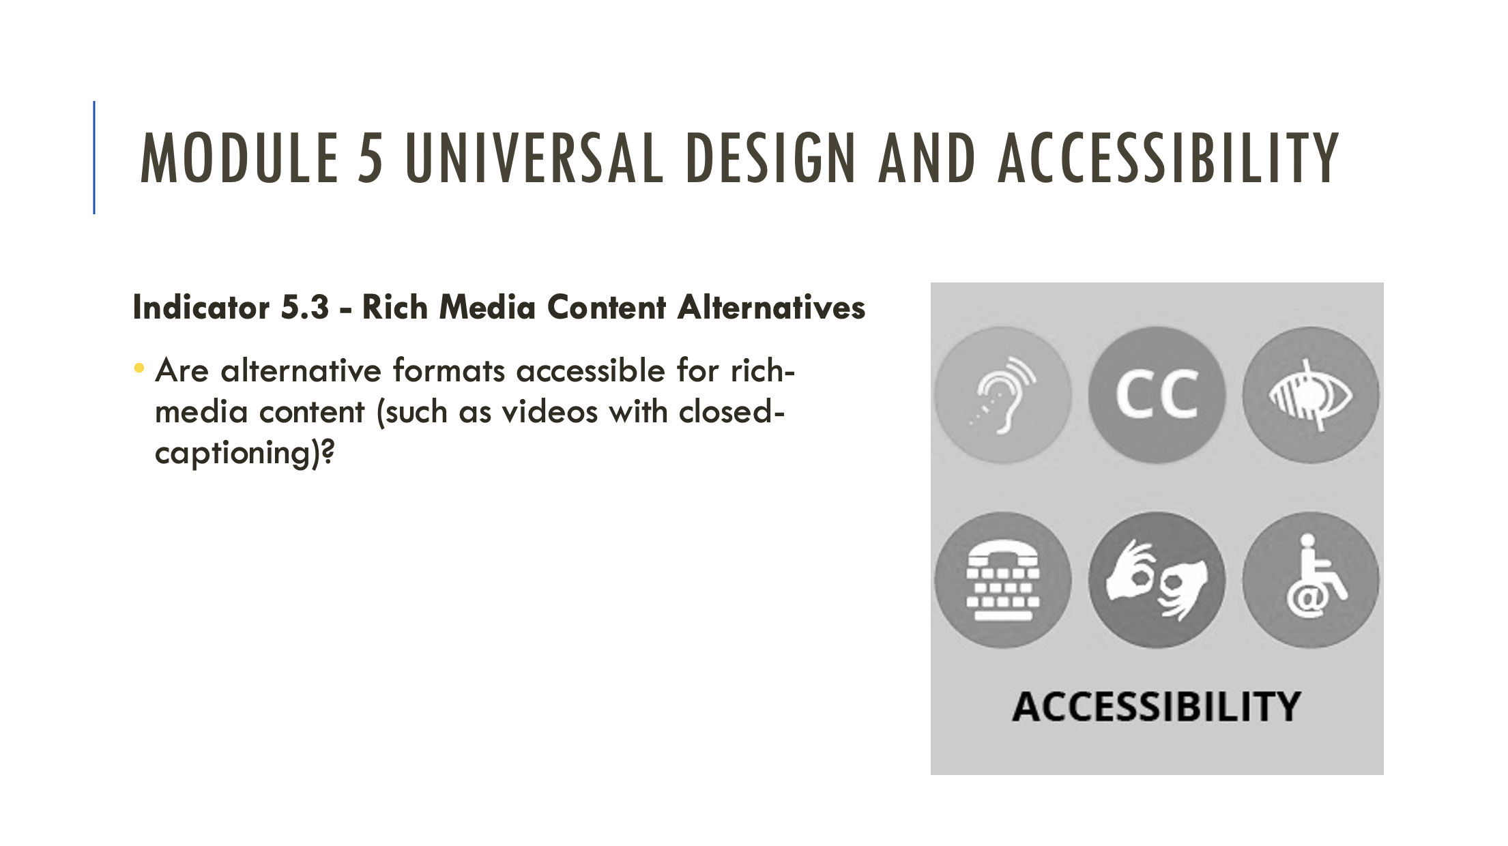

Q: What alternative formats do you provide for video-based content?
  - I ensure all videos I reference include closed captions
  - I create closed captions only for video content I create
  - What are closed captions?
  - I don’t include video-based content in my course.

