Bridging the Gap: Solving the Problem of Bringing Experiential Learning Activities to Online Capstone Courses
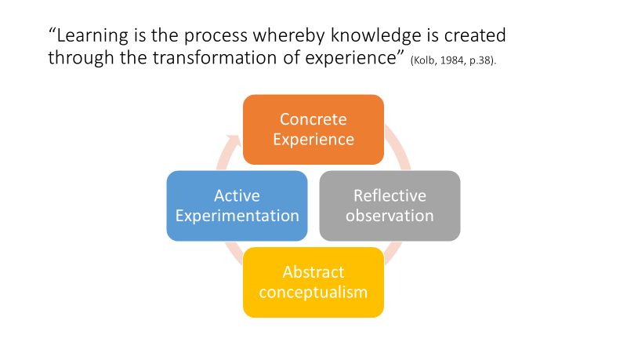

Reorganize the wheel of experiential learning for online learners
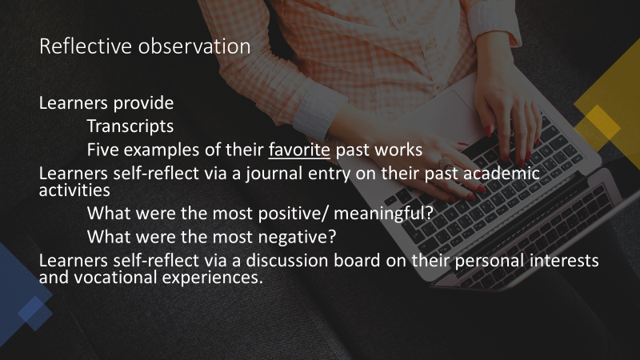
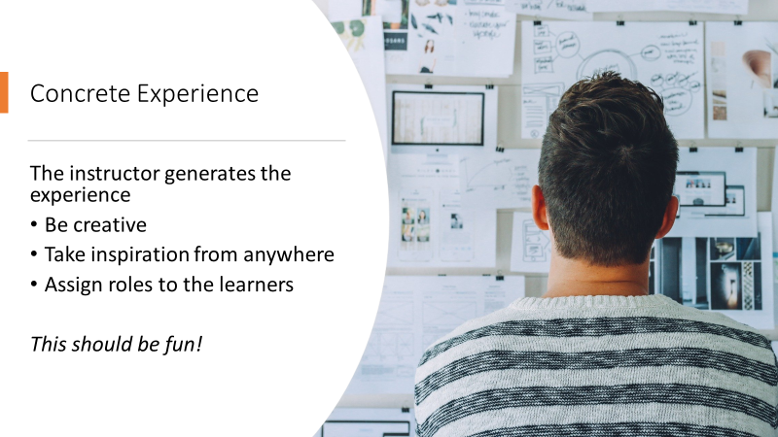

Example: The Case of the Prison Patients
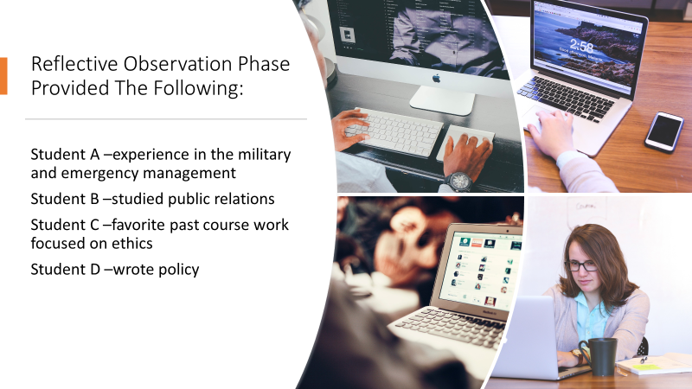
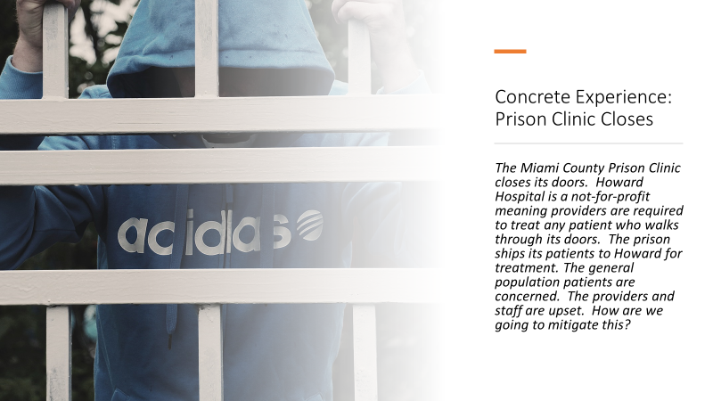
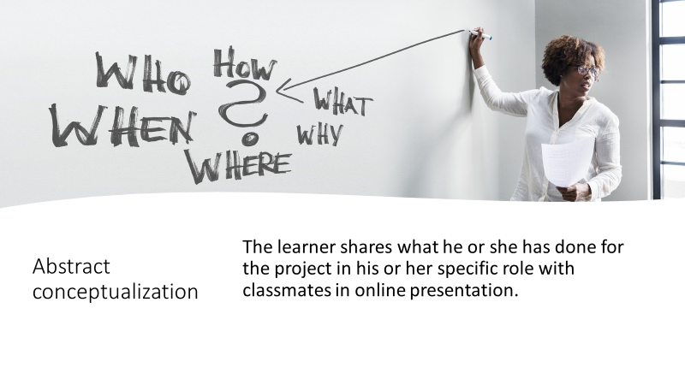
References
- Kolb, D.A. (1984). Experiential Learning: Experience As The Source of Learning and Development (Vol. 1). Englewood Cliffs, NJ: Prentice-Hall.
- Images from Pixabay.com

