Inclusive Campus Model Underpinned by the UDHE Framework

Reference: Burgstahler, S. (2020). Creating inclusive learning opportunities in higher education: A universal design toolkit. Harvard Education Press.
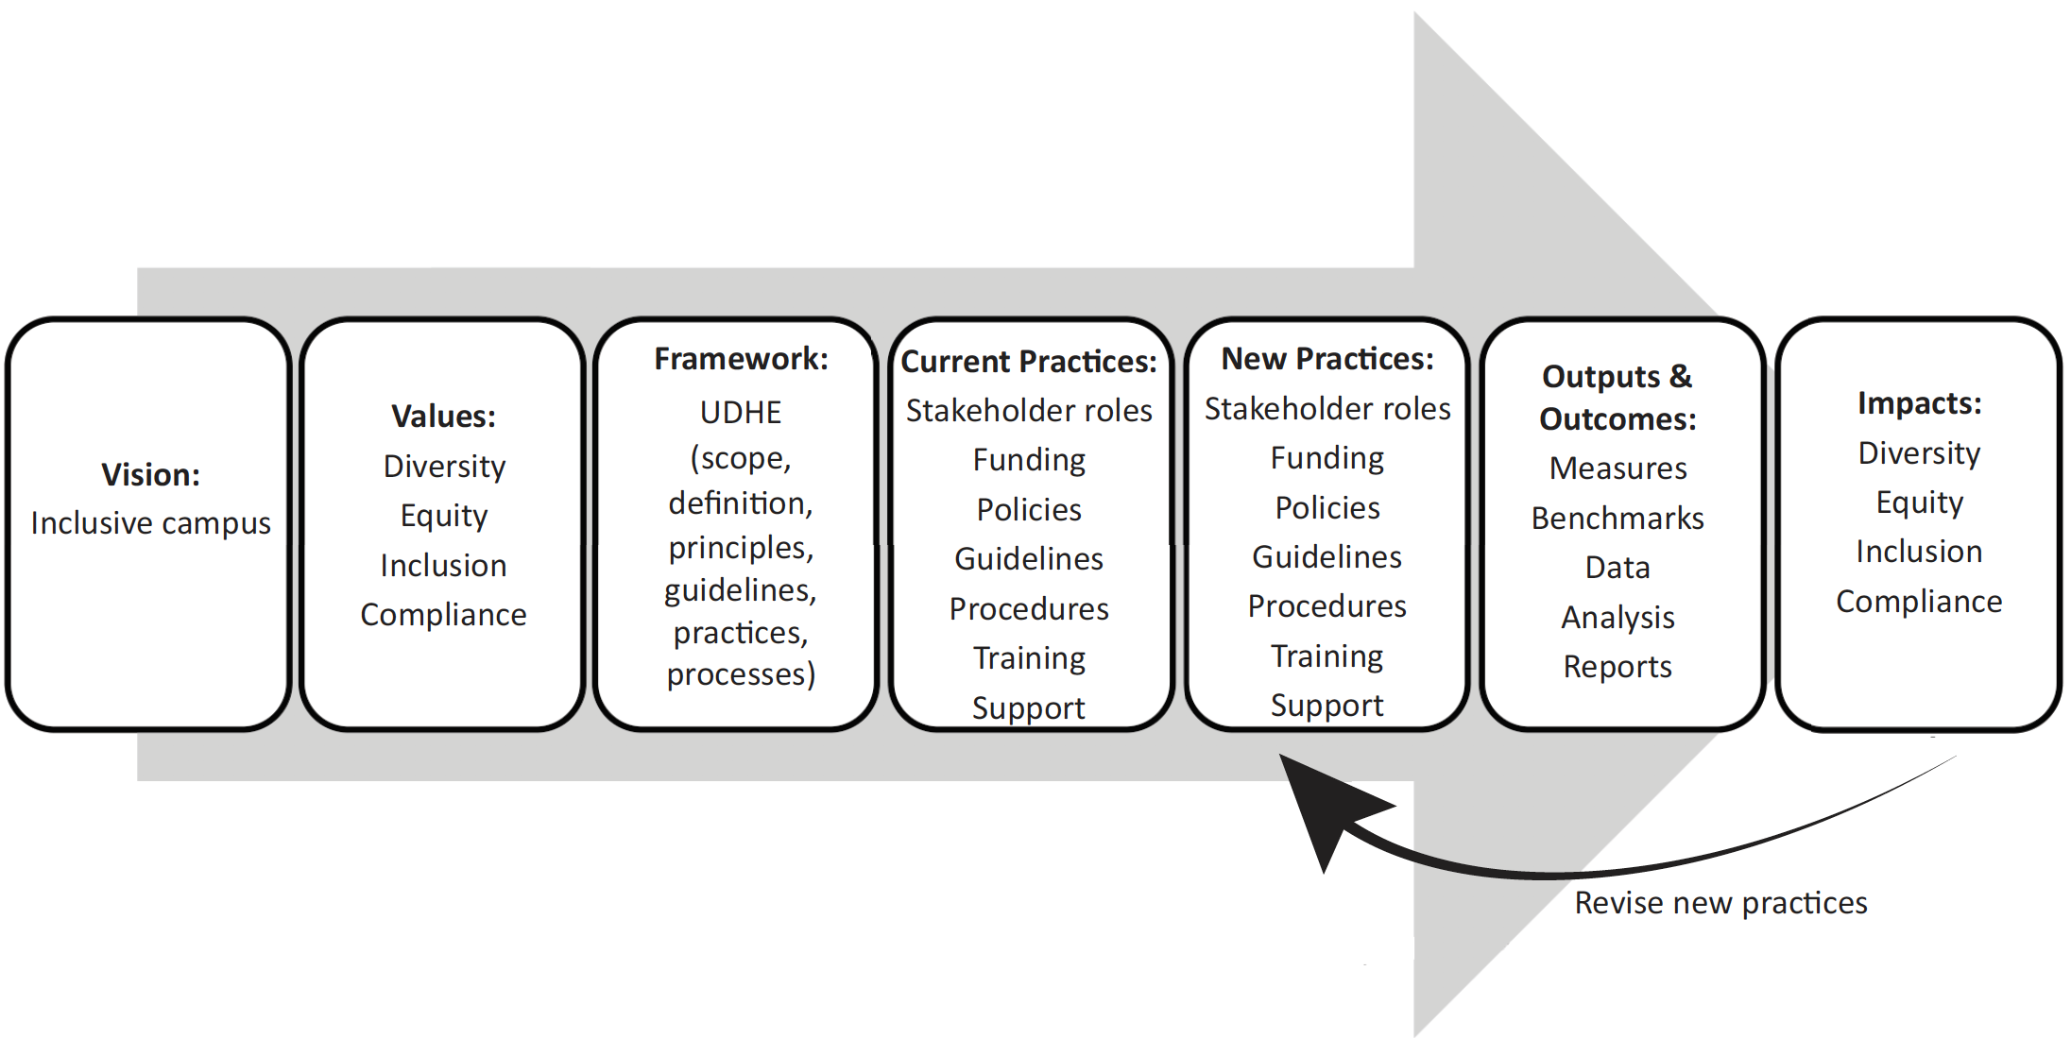

Example of UDHE Framework for University of Washington IT

Vision: @ UW: Inclusive campus. What is the vision for your campus?

Values: @ UW: Diversity, equity, inclusion, compliance. What campus values are most relevant for moving toward your vision?

UDHE Framework: Does the UDHE (or another) framework reflect your vision & values & can it guide your work toward a more inclusive program/campus?

@UW applied to IT:
Scope: Procurement, development & use of IT
Definition: “The design of IT products & environments in higher education to be usable by all people, to the greatest extent possible, without the need for adaptation or specialized design”
Principles: 7 UD+3 UDL+ 4 WCAG
Guidelines: Those built on UD, UDL, & WCAG principles
Practices: Practices built on UD, UDL, & WCAG guidelines
Process: Identify the application; define the “universe;” involve consumers; adopt guidelines/standards; apply guidelines/standards, plan for accommodations, training & support, evaluate

Assignment: Complete at least one aspect of Current/New Practices for Program or Campus

Current Practices: | New Practices:
Stakeholder roles:

Funding:

Policies:

Guidelines:

Procedures:

Training:

Support:

Other:

