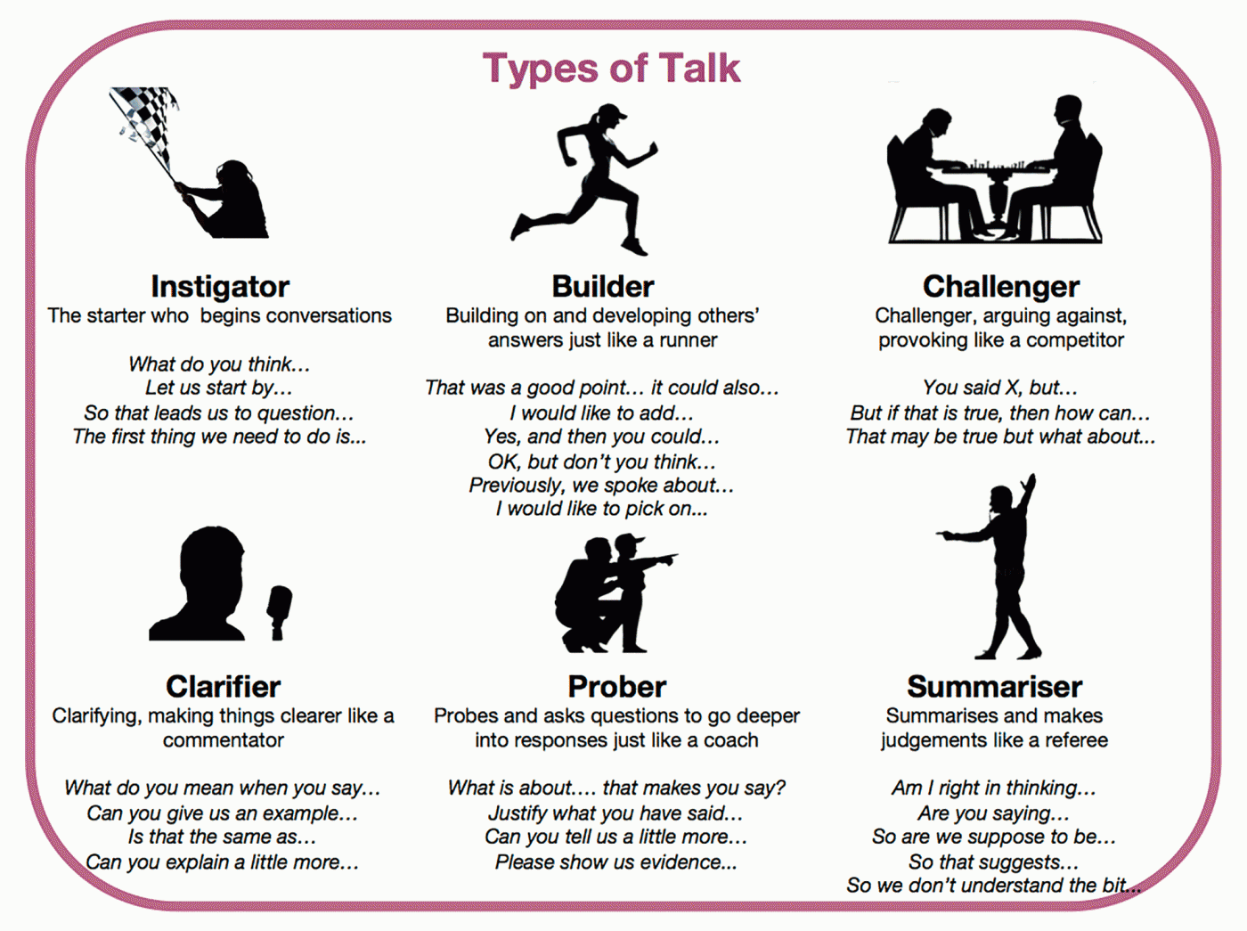
Adapted from https://www.edutopia.org/practice/oracy-classroom-strategies-effective-talk

Adapted from http://cet.usc.edu/resources/teaching_learning/material_docs/Asking_Better_Questions.pdf

