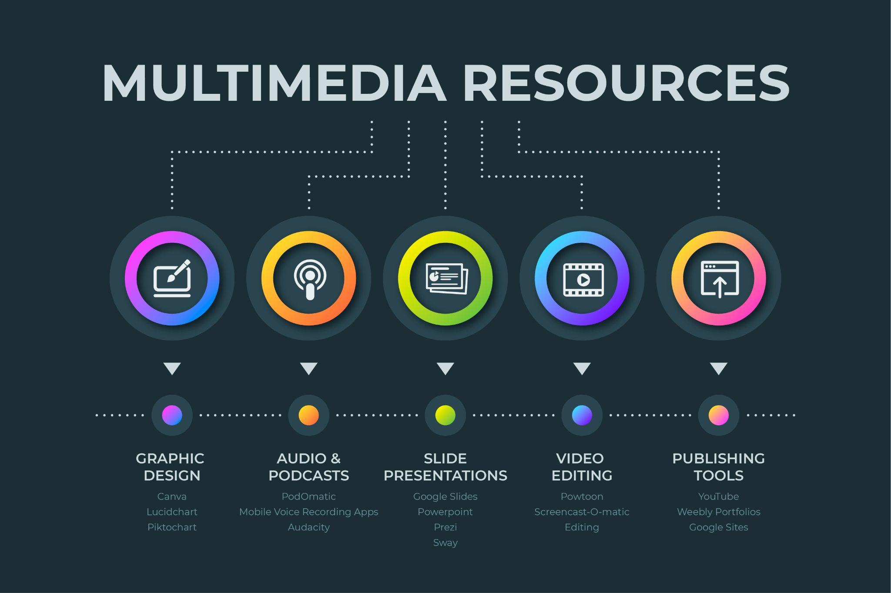

Graphic Design  Canva  Lucidchart  Piktochart  Podcast  PodOmatic  Mobile Voice Recording Apps  Audacity  Slide Presentations  Google Slides  PowerPoint  Prezi  Sway | Video  Powtoon  Screencast-O-Matic  Editing  Publishing  YouTube  Weebly Portfolios  Google Sites

