### 

## How Can You Connect the Dots?

What student learning and success indicators does your institution need to analyze institutional effectiveness? Where can you find these data at your institution? How can you connect multiple data sources? Consider the questions below in a Think-Pair-Share activity. Add your thoughts to the worksheet. Identify the systems you use in the first column. Use the dots to note the system’s function on our taxonomy and the data it contains by placing a red dot in the column for direct evidence and a black dot for indirect evidence. Discuss with someone nearby, then prepare to share as time allows.

* What are the data systems readily available to you? What kinds of data do they store? (direct, indirect, or both)
* What systems are available on campus that you need other experts to help you access? What kinds of data do they store? (direct, indirect, or both)

|  |  |  |  |  |  |  |  |
| --- | --- | --- | --- | --- | --- | --- | --- |
| *Taxonomy/Tool* | *Collecting* | *Connecting* | *Organizing* | *Archiving* | *Analyzing* | *Communicating* | *Closing the Loop* |
|  |  |  |  |  |  |  |  |
|  |  |  |  |  |  |  |  |
|  |  |  |  |  |  |  |  |
|  |  |  |  |  |  |  |  |
|  |  |  |  |  |  |  |  |
|  |  |  |  |  |  |  |  |
|  |  |  |  |  |  |  |  |
|  |  |  |  |  |  |  |  |

• UMBC • FDC & DOIT • Engineering 101 • 1000 Hilltop Circle • Baltimore, MD 21250 • www.umbc.edu •

# Got Data—Now What?: Synthesizing Outcomes, Measures, And Success to Inform Institution-Wide Decision Making

**• Jennifer M. Harrison, Faculty Development Center • Sherri N. Braxton, Instructional Technology •**

***LA3216***

BRIDGING STUDENT LEARNING OUTCOMES & ANALYTICS AT THE UNIVERSITY OF MARYLAND, BALTIMORE COUNTY

# Got Data—Now What?: Synthesizing Outcomes, Measures, And Success to Inform Institution-Wide Decision Making

**• Jennifer M. Harrison, Faculty Development Center • Sherri N. Braxton, Instructional Technology •**

***LA3216***

• UMBC • FDC & DOIT • Engineering 101 • 1000 Hilltop Circle • Baltimore, MD 21250 • www.umbc.edu •

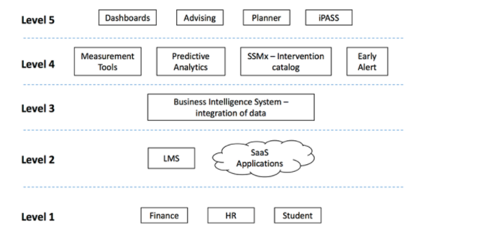

## Where Are Your Infrastructure Gaps?

Use the UMBC model shown in the slides as an example to explore the infrastructure levels at your institution. Which elements are already working to improve student learning and success and where/how is that data integrated? Use the stickers provided to complete the worksheet below.

BRIDGING STUDENT LEARNING OUTCOMES & ANALYTICS AT THE UNIVERSITY OF MARYLAND, BALTIMORE COUNTY