Virtual Classroom Training:
The Results of A Quantitative Study of
Synchronous Teaching Preparation
Glenn Kessler
Slide Deck

What We Don’t Know
Over the years the Babson Survey Research Group has conducted a series of surveys about online education -- this year’s edition is called the “Online Report Card.” The series began with a question: “How many students are learning online?” Thirteen years later, thanks to the efforts of the survey researchers and supporters, we’re in a much better position to answer that question.
We know, for example, distance education enrollment continues to grow, despite declining overall higher education enrollments. We know that 5.8 million students complete some or all of their classes online and we know that a significant majority of academic leaders believe online education is critical to their organization’s long-term strategy. But despite the explosion in online courses and students, there’s still a lot we don’t know about online education. For example, we know very little about how instructors are prepared to teach in an online environment and how they are prepared to deal with the many challenges online learning presents.
Those of us who teach in a synchronous virtual environment manage to overcome its various challenges, but there’s very little comprehensive research about the mechanisms that enable our success or, in some cases, drive our failures.
Teaching in a synchronous virtual classroom poses a host of unique challenges for instructors. Anyone stepping into the instructor’s role in a virtual classroom for the first time will feel overwhelmed. Unlike the ordered linear structure of a traditional face-to-face environment, it’s virtual chaos. Not only do you, the instructor, need to

- share engaging content,
- enable participant interaction and discussion

you also need to
- monitor chat messages or other social media,
- assess comprehension with real time polls and quizzes,
- randomize students called on,
- be alert for raised hands,
- create and monitor breakout sessions and … on top of all of this …
- deal with the inevitable technical issues ranging from uncooperative firewalls to recalcitrant headsets.
Using the full potential of a virtual classroom pushes the limits of even the most technically adept instructor.

A 2012 study of 4,500 faculty members posed the following question:

“Does the growth of online education fill you more with fear or with excitement?”

Administrators responsible for academic technology were asked the same question.
Nearly 60% of the faculty, as opposed to only 20% of administrators, said they were more filled with fear than excitement … by the growth of online learning. These results are not surprising. There are substantial technical and pedagogical hurdles that confront any instructor considering the transition to a virtual classroom. An instructor who enters a virtual classroom armed with only face-to-face tools, is unable to see – much less – realize its potential.

Corporate virtual instructor lead training (VILT) has met this challenge by making “producers” or “virtual classroom associates” – VCA’s -- a best practice in the corporate virtual training environment. A VCA is a tech-savvy co-pilot who helps the instructor navigate the virtual landscape. Since this corporate best practice is unavailable – not to mention unknown – to the majority of academics, we have to rely on our wits and our training to lead our students through the virtual wilderness.

Unfortunately, while the literature contains hundreds of articles about preparing instructors for the transition to online learning in general, very few focus on the specific challenges posed by synchronous learning environments – synchronous virtual classrooms. Even fewer investigate instructor preparation to meet these challenges:

- how much training virtual instructors receive,
- the nature of that training and
- the degree to which it’s successful.

This is the focus of our “Virtual Classroom Training Survey,” some outcomes from which I’d like to share with you in a moment. These outcomes, we believe, provide data for designing and implementing more effective training for virtual classroom instruction.

Demographics
In partnership with the OLC (and under the auspices of the UVA IRB), our team developed the survey instrument and deployed it to OLC’s mailing list and social media followers. 733 respondents completed the survey. This is certainly not a representative sample of all online instructors, much less all instructors in the US and beyond. However, we believe it does represent an important subset from which it is possible to draw a number of significant and actionable conclusions. Let’s begin with a brief respondent profile.

Here’s quick demographic overview of our survey respondents:

- 81% teach at university or four-year colleges,
- 21% at two-year community colleges or technical schools
- 71% untenured,
- 63% are full-time
- 40% Masters, 49% Ph.D.
- 84% have taught 5 years or more at the college level
- 61% are 50 years or older

Most respondents have online teaching experience:

- 91% taught an online course
- 56% -- 413 respondents -- have included a virtual – synchronous – component in a course
- 65% have taught online 5 years or more
- 72% have taught 5 or more online courses

In short, there’s a substantial amount of online experience – including virtual classroom experience -- in this respondent group of seasoned educators.

Among the respondents who had taught a course that included a synchronous virtual classroom, 66% (241) responded they had received training that addressed teaching in a synchronous virtual environment. This is only slightly higher than the 60% training rate across all respondents, whether or not they had taught in a synchronous environment. This suggests training programs are generic and not targeted to the specific needs of the instructors who participate in them.

Our first survey goal was to determine how much training is provided. Aggregating the results to parallel our poll, among all the instructors who received virtual classroom training, we have a bimodal distribution:

- 27% have received a month or more
- 32% have received less than a day
- On average instructors received 55% of their training before entering a virtual classroom for the first time.

So, at this point, our respondent profile looks like this. Our respondents have

- Demonstrated professional or personal interest in online education
- Affiliation with OLC
- Committed enough to respond to the survey
- Substantial teaching experience
- Substantial familiarity with online technologies
- Majority trained in their use

What the Survey Tells Us
What does this say about the survey? Where does it situate this survey with respect to the wider population of online instructors and – most importantly -- to what degree does it allow us to generalize the survey outcomes?

The survey respondents represent a “best case” scenario for virtual training. We can’t generalize from the fact that 66% of survey respondents receive virtual classroom training to the conclusion that 66% of all online instructors do. But we can be reasonably sure that the amount, kind and quality of training received by respondents -- with a stake in and commitment to online education -- sets a high bar that’s unlikely to be exceeded in a broader sample. The profile tells us we need to listen – and listen closely – to what these respondents tell us about virtual classroom training. But something is wrong. If this is accurate … if this is a “best case” scenario for virtual classroom training ... we have a problem.

Even among this experienced, formally trained and committed group of respondents, only 24% primarily rely on formal training to learn how to teach virtually. The rest – 76% -- are either mostly self- taught (50%) or mostly learn through informal conversations with peers who teach synchronously (26%). Of course this means we don’t really know what or how much this 76% learns about teaching in a synchronous environment, since there’s no assessment vehicle.

In fact, if we look at an even better case – instructors who have more than a month of training – only 39% find formal training the most useful vehicle for learning-to-teach in a synchronous virtual environment. This suggests we need to look at what this formal training involves. How do we train our virtual classroom instructors?

We asked respondents how large a role each of the following eight elements played in their training

- Discussion with other instructors in training
- Being a participant in a virtual classroom
- Reading relevant material
- Video training tutorials
- Workshops
- Listening to lectures
- Submitting written assignments
- Reviewing recordings of their performance as an instructor in a virtual classroom

- 40% said their training included little or no experience as a virtual classroom student
- 76% said their training included little or no review of their own performance, by way of recordings, in a virtual classroom

Overall, our training doesn’t help the instructor understand what it’s like to be a student in a virtual classroom – what the virtual experience is like from the students’ perspective – much less what’s it’s like to be a student in his or her own virtual classroom.

On the other hand

- 63% reported their training included a moderate to substantial amount of reading
- 57% reported their training included a moderate to substantial amount of video tutorial review
- 40% reported their training included a moderate to substantial amount of listening to lectures.

In short, and quite surprisingly, our current approach to virtual instructor training reflects the familiar “sage on the stage” paradigm – a paradigm that doesn’t play to the strength’s of a virtual classroom and should not be reinforced in this virtual environment.

We also asked respondents to indicate their level of participation in eight types of activities during their training:

- Teaching in a synchronous virtual classroom not monitored by a trainer
- Consultation with an instructional designer

- Peer coaching from a colleague

- Shadowing an experienced virtual learning instructor in a virtual classroom
- Teaching in a virtual classroom monitored by a trainer
- Teaching monitored by an experienced virtual classroom instructor
- Co-teaching with an experienced virtual classroom instructor
- Reviewing recordings of their performance in a virtual classroom

On the one hand:

- 44% reported a moderate or substantial amount of unmonitored teaching in virtual classroom and

On the other, nearly 80% of our respondents reported little or no

- shadowing an experienced virtual classroom instructor
- teaching in a virtual classroom monitored by a trainer

- teaching in a virtual classroom monitored by an experienced virtual classroom instructor
- co-teaching in a virtual classroom with an experienced virtual instructor
- reviewing recording of their own performance in a virtual classroom

In other words, working with an experienced virtual-classroom instructor or training within a virtual classroom environment plays a minimal role in our current approach to virtual instructor training.
As one of our respondents observed, “practice makes perfect” … but only if we practice the right things in the right way. Our training seems to ignore this fundamental principle of successful coaching.

We also asked respondents about the modalities through which the training was delivered: face-to-face, asynchronous, synchronous

- 41% of our respondents said synchronous activities played little or no role in their virtual classroom training

- for only 30% did synchronous activities play a substantial role.

Synchronous activities don’t play a predominant role in learning to use synchronous technology. This is very much like teaching someone to play the piano by having them read biographies of great pianists or trying to get to the moon by climbing a ladder. Some of the work gets done, but the heavy lifting – the bulk of the training – is left unaddressed. And the results are … as you would expect.

We asked respondents about the perceived effectiveness of their training as well as their confidence as a virtual-classroom instructor. We then compared these results across the following independent variables.

- Amount of training
- Who provided the training
- Institutional commitment to training
- Use of synchronous components in training

Very little training – an hour or less -- appears to affect an instructor’s perceived effectiveness in the virtual classroom. After 1 hour of training only 35% of respondents perceive themselves as moderately or substantially effective. An hour of training is not sufficient. But this is the only meaningful correlation we can draw between the amount of training and its perceived effectiveness. After a day of training 82% of respondents perceive themselves as moderately or substantially effective. After both a week and a month of training, 73% of respondents perceive themselves as moderately or substantially effective. And after over a month of training 91% of instructors perceive themselves as moderately or substantially effective.

In terms of perceived effectiveness, the return on more than a day of training doesn’t appear to warrant the investment. Amount of training appears to make a difference, but apart from the extremes, it’s difficult to detect a significant pattern. (See Appendix I.)
With respect to confidence it’s difficult to detect any correlation at all.

How does the training provider affect perceived effectiveness and confidence?
The categories we included were

- Your university/institution
- Peers through informal coaching
- Support modules available through the synchronous training platform
- An external training provider … not through your university/institution
- Generally available on-line training
- An external training provider or learning organization through your university/institution
- A professional organization

There seems to be no significant variation across training provider on either perceived effectiveness or confidence. (See Appendix II.)

What about institutional policy towards training? How does this affect perceived effectiveness and confidence? We considered three categories:

- My institution requires instructors to be formally trained in online techniques.
- My institution actively encourages instructors who are teaching online to seek out formal training.
- At my institution, there is no policy regarding training for online teaching.

While the lack of a policy concerning training for online teaching may have an impact on instructor effectiveness, perceived effectiveness appears ambivalent between required and actively encouraged training.

Once again institutional policy towards training seems to be decoupled from instructor confidence in the virtual classroom. (See Appendix III.)

But the situation is radically different with our fourth independent variable: using synchronous components in training. (See Appendix IV.)

- 89% of those respondents for whom synchronous activities played a substantial role in their training, perceived themselves to be moderately or substantially effective in the virtual classroom.
- 51% of those respondents perceived themselves to be substantially effective in the virtual classroom – compared to only 20% of instructors whose training included no synchronous component.

This strongly supports our earlier – intuitive -- observation that substantial use of a synchronous training activities in virtual classroom training yields substantially more effective synchronous instructors … and far more confident ones as well.

Significant use of synchronous activities in virtual classroom training --is the only variable we’ve so far encountered that substantially moves the needle for both perceived effectiveness and confidence.

What Next?
So where do we go from here? What should virtual classroom training include? What do our colleagues tell us? We offer three key learnings from this survey, the first of which should already obvious:

1. Use synchronous components in virtual classroom training.

Teaching effectively – inside of a virtual classroom or out – requires more than knowing what to do. It requires knowing how to do it. Our colleagues are telling us that both effectiveness and confidence in the virtual classroom require that synchronous components play a large role in virtual classroom training.

You can’t learn to cross country ski by watching a video on YouTube. Why should it be any different for the skills that support virtual classroom instruction?

As discussed above, we first asked respondents how much emphasis was actually placed various elements in their training. Our current training places significantly more emphasis on learning the technology platform than adapting pedagogy or content to this new environment. But we also asked our respondents

Q31. In retrospect, if you had to design training for instructors new to the virtual classroom, how much emphasis would you place on each of the following?
Given your knowledge and experience how would you do it? And … they would do it quite differently.

Our colleagues tell us that our training orientation needs to shift from a focus on the technology to the more the balanced approach suggested by Koehler and Mishra in the TPACK model. This is the second key learning:

2. Change the training orientation.

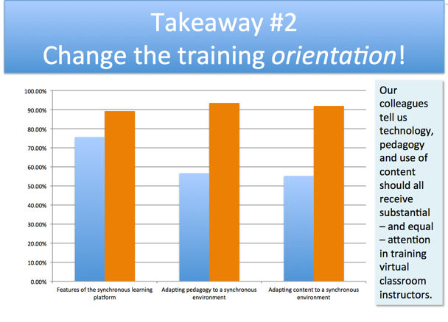
They’re also telling us we need to rethink the elements that comprise the current virtual classroom-training regime.

Q32. In your opinion, how effective are these elements in helping instructors new to synchronous training become productive virtual classroom instructors?
Forget about what you did in your training; what should you have done? What can we learn from your experience as a virtual classroom instructor? Here’s what our colleagues say:

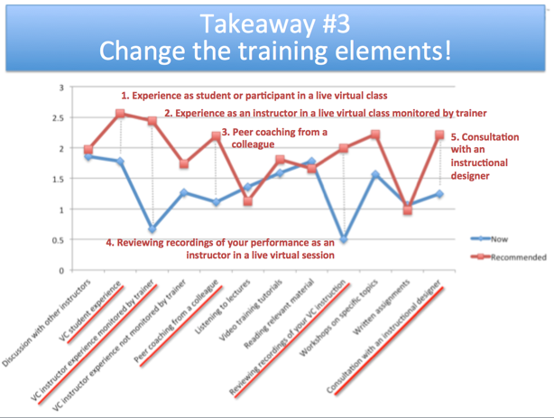

This is our final (for now) key learning from the survey:

3. Change the training elements.

As clearly demonstrated in this graph our colleagues are telling us to focus on five key elements to increase the effectiveness of virtual classroom training:

- Experience as student or participant in a live virtual class
- Experience as an instructor in a live virtual class monitored by trainer
- Peer coaching from colleagues
- Reviewing recordings of your performance as an instructor in a live virtual session
- Consultation with an instructional designer

On the flip side we need to decrease the current emphasis on listening to lectures, reading relevant material and written assignments. We need to move from passive information retention to active skill building and creative application of these powerful new tools.

As academics and educators this comes as no surprise. But putting these learnings into practice has proved surprisingly difficult. We hope this survey is a first step in a new direction for virtual classroom training.
Research Team

Glenn Kessler, Ph.D.
University of Virginia

Michele Lewski, Ph.D.
Stevens Institute of Technology

Jennifer Withrow
Align Virtual Learning Solutions

Kathryn F. Wood, Ph.D.
University of Virginia Faculty

Appendix I: Amount of Training v. Perceived Effectiveness
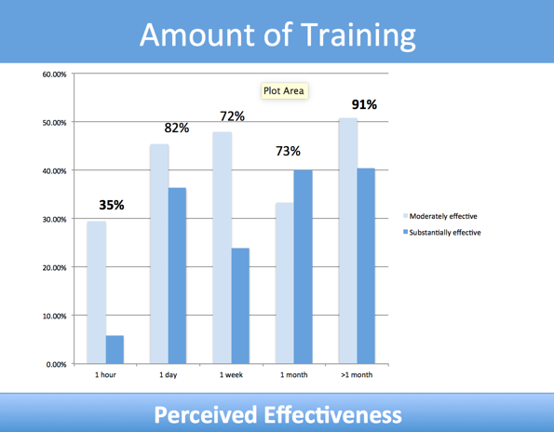

Appendix II: Training Provider v. Perceived Effectiveness
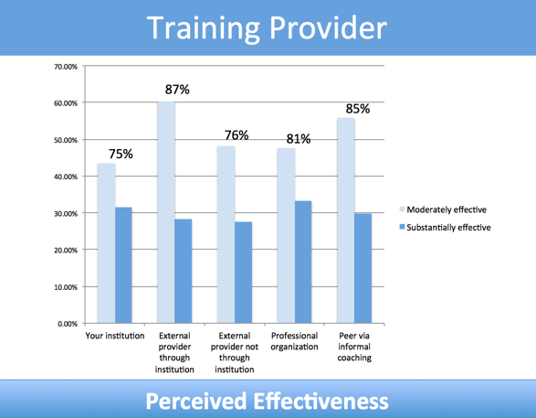

Appendix III: Institutional Policy v. Perceived Effectiveness
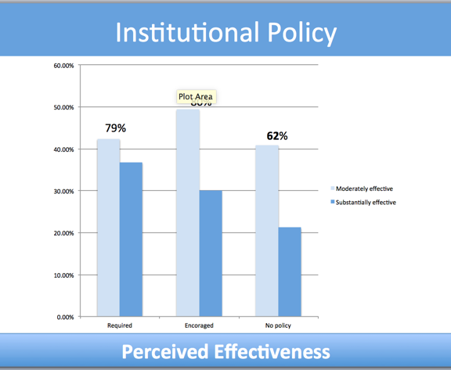

Appendix IV: Use of Synchronous Components v. Perceived Effectiveness
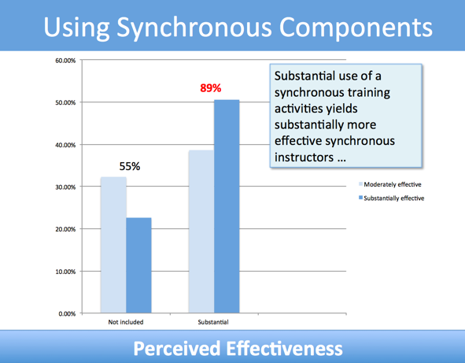

I. Elaine Allen & Jeff Seaman, “Online Report Card: Tracking Online Education in the US” (Babson Survey Research Group, 2016)
Allen & Seaman, “Changing Course,” p. 4
Ibid., p. 5

